Robotic Sorting System

Pace Dominy

Joseph Miller

Lam Tran

**Functional System Requirements**

**Android Application**

REVISION 1

3 October 2022

Functional System Requirements

for

Robotic Sorting System (Android Application)

Prepared by:

_____________________________

Joseph Miller Date

Approved by:

_____________________________

Project Leader Date

_____________________________

John Lusher, P.E. Date

_____________________________

T/A Date

**Change Record**

|  |  |  |  |  |
| --- | --- | --- | --- | --- |
| **Rev.** | **Date** | **Originator** | **Approvals** | **Description** |
| **1** | 10/3/2022 | Joseph Miller |  | Draft Release |

Table of Contents

Table of Contents III

List of Figures IV

1. Introduction 1

1.1. Purpose and Scope 1

1.2. Responsibility and Change Authority 1

2. Applicable and Reference Documents 2

2.1. Applicable Documents 2

2.2. Order of Precedence 2

3. Requirements 3

3.1. System Definition 3

3.2. Characteristics 4

3.2.1. Functional / Performance Requirements 4

3.2.2. Physical Characteristics 4

3.2.3. Electrical Characteristics 4

3.2.4. Environmental Characteristics 5

3.2.5. Failure Prevention 5

4. Support Requirements 6

Appendix A: Acronyms and Abbreviations 7

List of Figures

Figure 1. Block Diagram of System 3

# Introduction

## Purpose and Scope

This Functional Requirements Document (FSR) defines the technical requirements for the Android application that serves as the primary user interface for the Robotic Sorting System. The verification requirements for the project are contained in a separate Verification and Validation Plan.

The following definitions differentiate between requirements and other statements.

Shall: This is the only verb used for the binding requirements.

Should/May: These verbs are used for stating non-mandatory goals.

Will: This verb is used for stating facts or declaration of purpose.

## Responsibility and Change Authority

At the subsystem level, the team member in charge of the Android application subsystem (Joseph Miller) is responsible for ensuring that the Android application meets all requirements specified in the project-level FSR. The requirements stated in this document may only be changed with the approval of the application subsystem leader (Joseph Miller), the project leader (Pace Dominy), and Dr. John Lusher.

# Applicable and Reference Documents

## Applicable Documents

The following documents, of the exact issue and revision shown, form a part of this specification to the extent specified herein:

|  |  |  |
| --- | --- | --- |
| **Document Number** | **Revision/Release Date** | **Document Title** |
| Bluetooth SIG 5.0 | 06 December 2016 | Bluetooth Core Specification v5.0 |
| RSS ICD | 1.0/3 October 2022 | Robotic Sorting System Interface Control Document |
| RSS AAICD | 1.0/3 October 2022 | Android Application Interface Control Document |

## Order of Precedence

In the event of a conflict between the text of this specification and an applicable document cited herein, the text of this specification takes precedence without any exceptions.

All specifications, standards, exhibits, drawings or other documents that are invoked as “applicable” in this specification are incorporated as cited. All documents that are referred to within an applicable report are considered to be for guidance and information only, except ICDs that have their relevant documents considered to be incorporated as cited.

# Requirements

This section defines the requirements of the Android application to ensure proper functionality and integration with the larger Robotic Sorting System project.

## System Definition

The Android application for the Robotic Sorting System (RSS) is the primary user interface that the operator uses to interact with the System, consisting of an application that runs on a separate Android device (the user’s personal device or one provided by the purchasing organization).

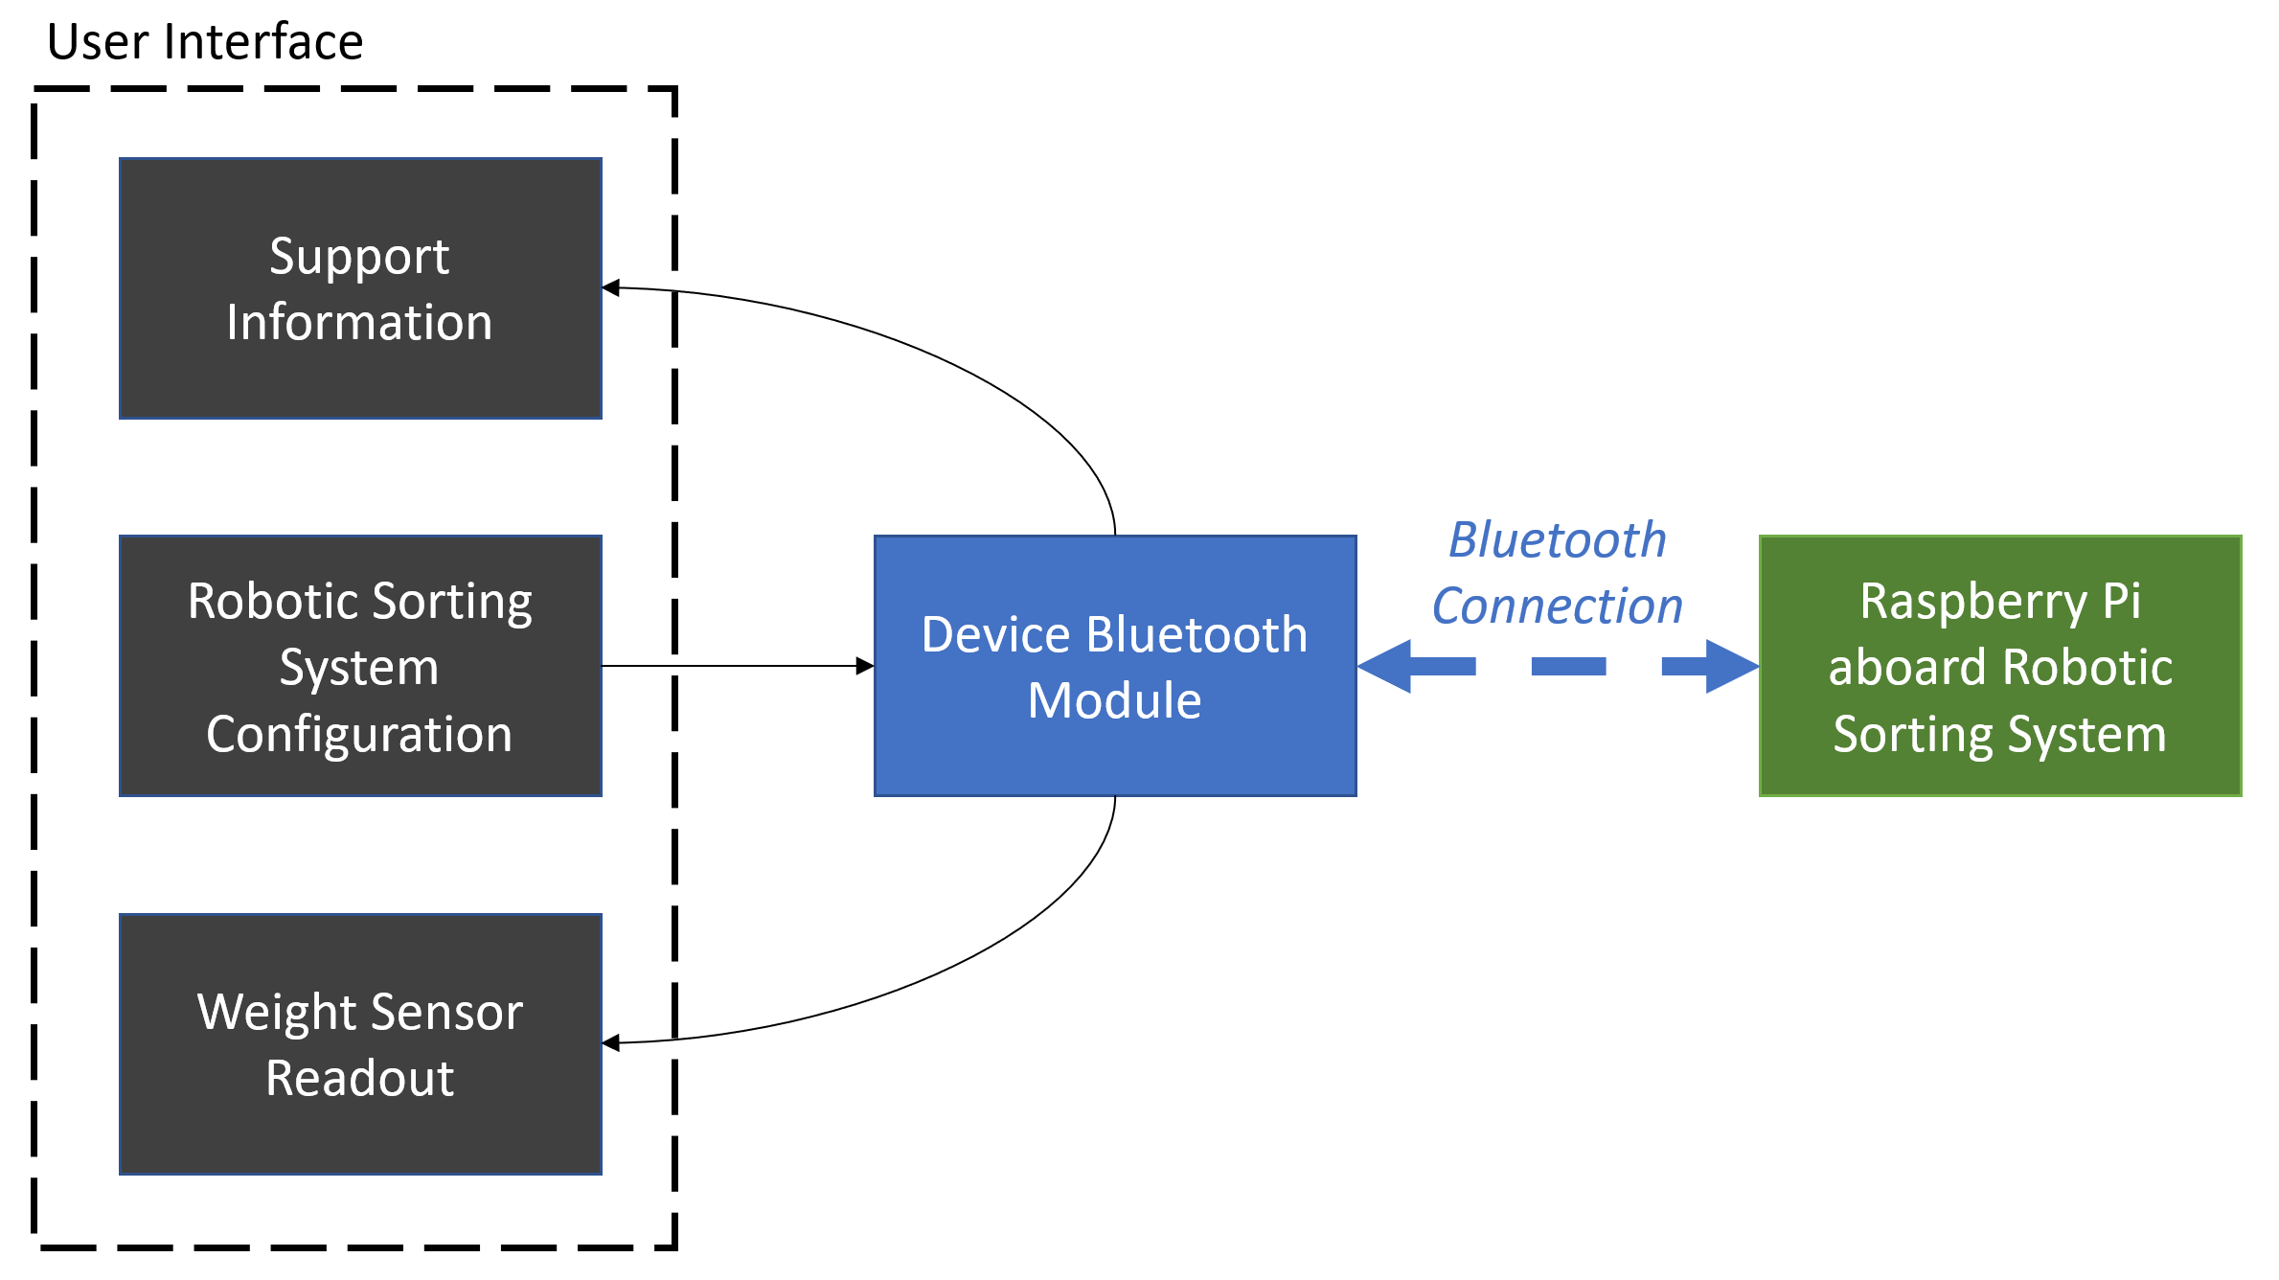

Figure . Block Diagram of System

The user interface consists of three primary components: support information, sorting system configuration, and weight sensor readouts. The first component, support information, provides a full copy of the user manual and the manufacturer’s contact information for quick reference. The application also shows diagnostic information and error messages returned from the Robotic Sorting System for easy, human-readable troubleshooting.

The second function of the application is to allow easy configuration of the Robotic Sorting System. Using a Material Design-based Android graphical user interface (GUI) makes changing the sorting configuration simple and similar (in terms of GUI) to many popular Android apps.

The Android application also serves as the user’s primary interface with the weight sensors. The data that the sensors collect is transmitted via Bluetooth to the application, where the user can easily find it.

## Characteristics

### Functional / Performance Requirements

#### Android Version Compatibility

The Android application shall target and be primarily designed for Android API level 31, which corresponds to Android 12. It shall be compatible with devices running Android versions 9.0 and higher. The primary Android device used for testing will be a 2020 Galaxy Tab S6 Lite running Android 12.0.

Rationale: Google requires that new Android applications uploaded to the Google Play store target Android API level 31 as of August 1st, 2022. Because Google does not officially support Android versions older than 9.0 as of October 3rd, 2022, Android 9.0 will be the cutoff for application support. Using an Android 12-based device ensures that the application will work well with the targeted version of Android.

#### Device Form Factor Compatibility

The Android application shall run on smartphones and tablets running Android.

Rationale: Android smartphones and tablets are widely available and provide the best screen space and utility for the kind of data that the application will handle. Other Android-based devices (smartwatches, car navigation systems, smart TVs, etc.) do not have enough screen space to make the application useful or are not relevant to a farming operation.

#### Programming Language and Development Environment

The Android application shall be developed using the Android Studio development environment in the Kotlin programming language.

Rationale: Android Studio and Kotlin are Google’s current preferred environment and language for building Android applications. This means that Google has significant resources available for learning these tools, making the development process as straightforward as possible.

### Physical Characteristics

#### Application Size

The Robotic Sorting System Android application shall take up no more than 30 MB of space.

Rationale: The most popular Android applications on the Google Play store were approximately 55-73 MB in size [as of February 2022](https://www.statista.com/statistics/1296527/size-top-android-apps/). Because this application will be significantly less complex than those apps, it should be no greater than half of the size of the most popular apps.

### Electrical Characteristics

#### Inputs

No sequence of commands to the Android application shall damage or reduce the life expectancy of the Robotic Sorting System.

Rationale: By design, should limit the chance of damage or malfunction by user/technician error.

### Environmental Characteristics

The Bluetooth functionality of the Android device will be tested at 15°C, 22°C, and 35°C.

Rationale: The Bluetooth Core Specification v5.0 requires that Bluetooth connections be tested for operation between 15°C and 35°C. Room temperature (~22°C) will also be used as a middle-ground testing point.

#### Outputs

##### System Configuration Output

The Android application shall provide configuration data to the Robotic Sorting System that will then be used to configure the logic of the robotic arm.

Rationale: The Android application acts as the primary configuration interface for the Robotic Sorting System.

##### Diagnostic Output

The Android application shall include a diagnostic readout system to help identify and resolve problems with the system.

Rationale: A diagnostic readout system makes it significantly easier to identify problems with the Robotic Sorting System so that it can be easily resolved.

#### Connection

The Android application shall establish and use a Bluetooth connection in accordance with the Bluetooth Core Specification version 5.0 to transmit and receive data.

Rationale: The use of Bluetooth ensures compatibility with a wide range of Android devices. Version 5.0 of the Core Specification will be used because the Raspberry Pi that the Android device will connect to has a Bluetooth 5.0-capable processor.

### Failure Prevention

The Android application shall not allow faulty configurations to be transmitted to the Robotic Sorting System.

#### Failures from Incorrect Inputs

##### Incompatible Configuration Detection

The Android application shall detect when the user attempts to pass a sorting configuration that the System cannot accomplish.

Rationale: This will ensure that a user’s sorting configuration does not damage the equipment or provide a greatly inaccurate sorting result.

##### Failure Recovery

Upon an attempt to apply an incompatible configuration, the Android application will push a notification to the user. It will not apply an incompatible configuration.

Rationale: This prevents incompatible configurations from being applied to the machine, ensuring that the machine functions as intended and does not damage itself in the process.

# Support Requirements

To run the Robotic Sorting System Android application, the user must have an Android smartphone or tablet with Bluetooth compatibility and running Android 9.0 or higher. Support for the application will be included as part of the user manual available in the application. For issues that the user manual does not resolve, the contact information for the manufacturer of the Robotic Sorting System and the developers of the Android application will be provided in the manual and in the application. Depending on the nature of the issue, a technician may be dispatched to the customer for repair, or the customer may be able to start a return/replacement process.

# Appendix A: Acronyms and Abbreviations

API Application Programming Interface

App Short for “application”

FSR Functional System Requirements

GUI Graphical User Interface

ICD Interface Control Document

MB Megabyte(s)

RSS Robotic Sorting System

SIG Special Interest Group